Test Project
IT Network Systems Administration
Module D: Troubleshooting

Contents
Contents 2
Instructions 3
Network Topology 4
Annex A：Network Information 5

Instructions
- The competition has a fixed start and finish time. You must decide how to best divide your time.
- Please carefully read the following instructions.
- There will be 10 “Troubleshooting tickets” to solve, each ticket describes a situation from a user perspective.
- All Competitors will receive printed copy of the tickets in English, If you don't understand the meaning of the question, you can use offline translation software to translate.
- The competitors have to provide answers regarding “What are the cause of the problem” and the “Recommended solutions to fix this” for each Troubleshooting ticket.
- The Marking Team will only verify the contestant's handwritten troubleshooting tickets.
Important, please be aware that you are NOT required to physically fix the problem, you only need to “describe” the cause of the problem and the recommended solution to fix it. Every ticket has at least one cause, with possible additional related or unrelated causes. You need to identify these causes to the problem and provide recommended solutions to fix the problem.
All the VM and network devices’ usernames, passwords and IP addresses etc. within the troubleshooting scenario are presented on Annex A.
For all answers submitted, the Marking Teams will NOT judge your spelling, grammar, or wordings, only the actual cause and solutions.

Network Topology

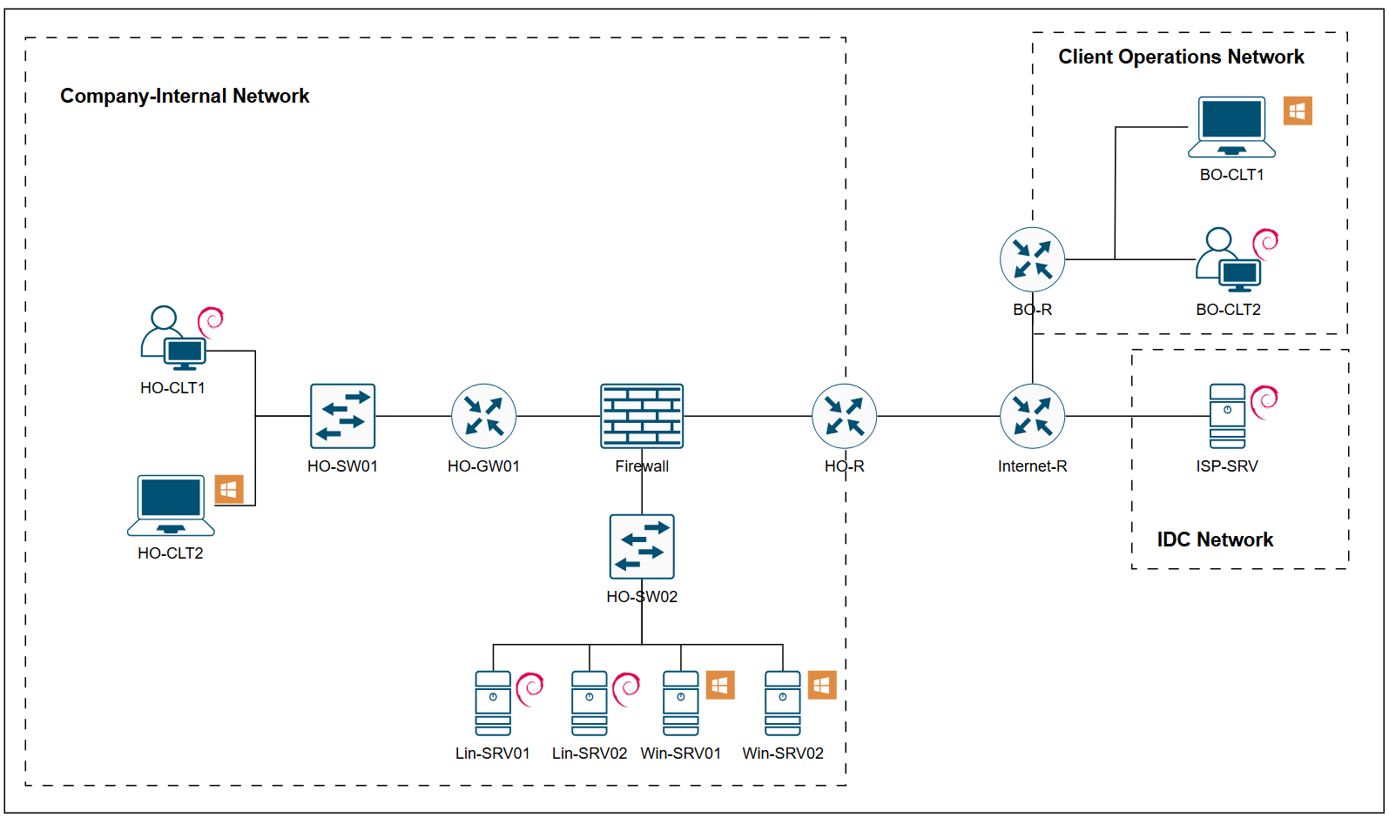

Annex A：Network Information
Device | IP Address | Services | Operation System | Credentials
HO-R | 172.31.255.94/27 | Routing,EIGRP,OSPF,NAT,Tunnel VPN | Cisco IOSv | Cisco1@3
HO-R | 182.210.167.5/29 | Routing,EIGRP,OSPF,NAT,Tunnel VPN | Cisco IOSv | Cisco1@3
HO-R | 10.0.0.10/24 | Routing,EIGRP,OSPF,NAT,Tunnel VPN | Cisco IOSv | Cisco1@3
Firewall | 172.31.255.93/27 | Routing,EIGRP | Cisco ASAv | Admin  Cisco1@3
Firewall | 172.31.255.30/27 | Routing,EIGRP | Cisco ASAv | Admin  Cisco1@3
Firewall | 172.16.2.254/24 | Routing,EIGRP | Cisco ASAv | Admin  Cisco1@3
HO-GW01 | 172.31.255.29/27 | Routing,EIGRP,DHCP Relay | Cisco IOSv | Cisco1@3
HO-GW01 | 172.16.1.254/24 | Routing,EIGRP,DHCP Relay | Cisco IOSv | Cisco1@3
HO-SW01 | 172.16.1.101/24 | Vlan,DHCP Snooping | Cisco IOSv | Cisco1@3
HO-SW02 | 172.16.2.101/24 | Vlan | Cisco IOSv | Cisco1@3
Internet-R | 182.210.167.6/29 | Routing,OSPF | Cisco IOSv | Cisco1@3
Internet-R | 163.108.25.6/29 | Routing,OSPF | Cisco IOSv | Cisco1@3
Internet-R | 203.156.27.254/24 | Routing,OSPF | Cisco IOSv | Cisco1@3
BO-R | 163.108.25.5/29 | Routing,OSPF,NAT,Tunnel VPN | Cisco IOSv | Cisco1@3
BO-R | 172.16.3.254/24 | Routing,OSPF,NAT,Tunnel VPN | Cisco IOSv | Cisco1@3
BO-R | 10.0.0.20/24 | Routing,OSPF,NAT,Tunnel VPN | Cisco IOSv | Cisco1@3
HO-CLT1 | DHCP | \ | Linux Client | root / skills  Pa$$w0rD
HO-CLT2 | 172.16.1.10/24 | AD Domain Client | Windows Client | skills  P@ssW0rD
Lin-SRV01 | 172.16.2.201/24 | DHCP,Web | Linux Server | root / skills  Pa$$w0rD
Lin-SRV02 | 172.16.2.202/24 | Mariadb | Linux Server | root / skills  Pa$$w0rD
Win-SRV01 | 172.16.2.203/24 | ADDS,ADCS,DNS | Windows Server | Administrator  P@ssw0rD
Win-SRV02 | 172.16.2.204/24 | AD Domain Member Server | Windows Server | Administrator  P@ssw0rD
ISP-SRV | 203.156.27.200/24 | Web,DNS | Linux Server | root / skills  Pa$$w0rD
BO-CLT1 | 172.16.3.100/24 | \ | Windows Client | skills  P@ssW0rD
BO-CLT2 | 172.16.3.200/24 | \ | Linux Client | root / skills  Pa$$w0rD
Note：Domain Users default password is “P@ssw0rD”

