Nginx 配置案例

80 默认站点
#server
apt install nginx -y
/etc/nginx/sites-enabled/default
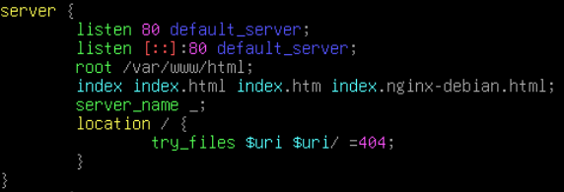

443 默认站点 SSL
/etc/nginx/sites-enabled/default
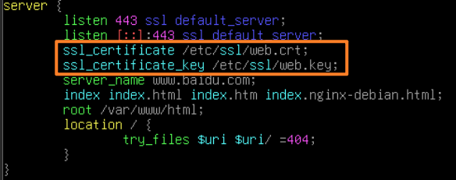

PHP支持
apt install php8.2-fpm -y
/var/www/html/index.php
/etc/nginx/sites-enabled/default
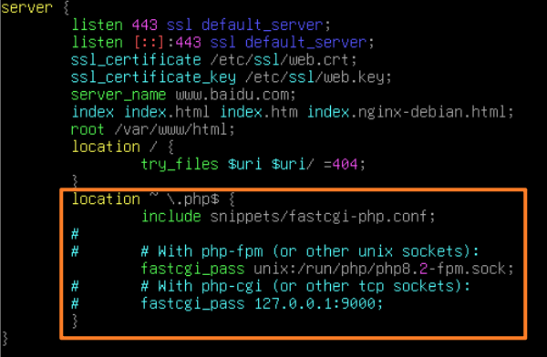
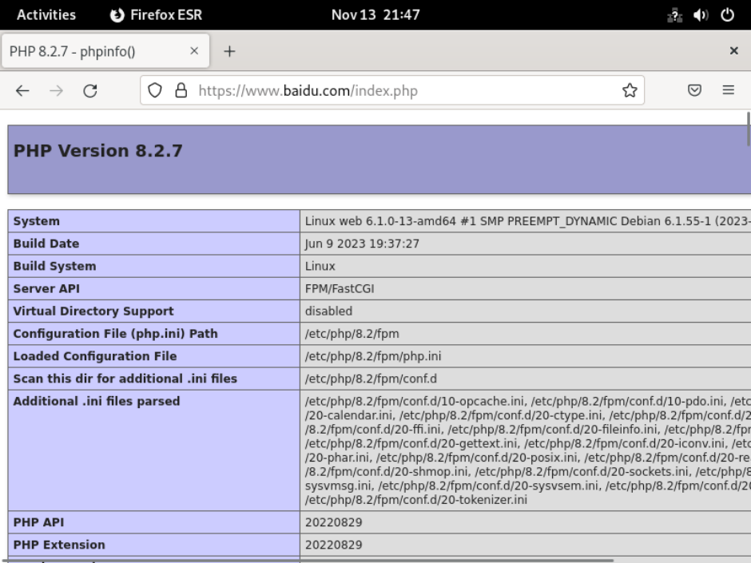

http跳转 https + ip 和其他域名拒绝 + wordpress + log
apt install wordpress mariadb-server php8.2 -y
cp -r /usr/share/wordpress/* /var/www/html -r
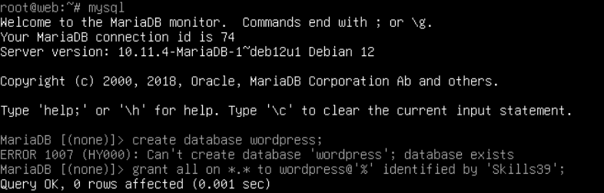
cp /var/www/html
chmod 777 /var/www/html*
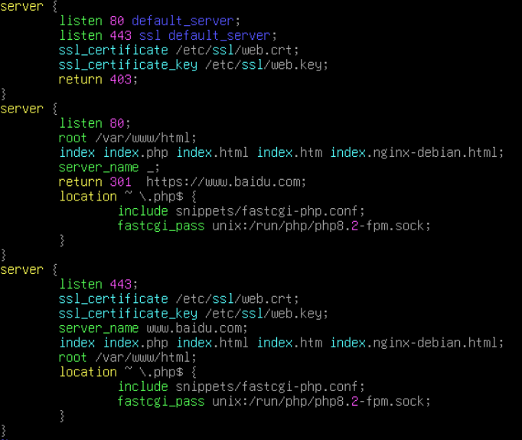
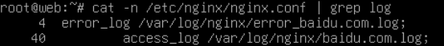

ansible 配置wordpress
---
- name: Deploy WordPress
hosts: server01
become: true
tasks:
- name: Install WordPress Packages
apt:
name: "{{ packages }}"
state: present
update_cache: no
vars:
packages:
- wordpress
- php7.4-fpm
- mariadb-server
- nginx
- python3
- python3-mysqldb

- name: Configure WordPress Database
mysql_db:
name: wordpress
state: present

- name: Configure MySQL User
community.mysql.mysql_user:
name: zhaixing
password: 'Skills39!'
priv: '*.*:ALL'
state: present

- name: copy wordpress to nginx web main directory
ansible.builtin.raw: cp -r /usr/share/wordpress/* /var/www/html/
- name: copy wp-config.php
ansible.builtin.copy:
src: /root/wp.php
dest: /var/www/html/wp-config.php
- name: copy nginx conf
ansible.builtin.copy:
src: /root/default
dest: /etc/nginx/sites-enabled/default
notify: restart nginx

- name: restart nginx
service:
name: nginx
state: restarted

wp.php
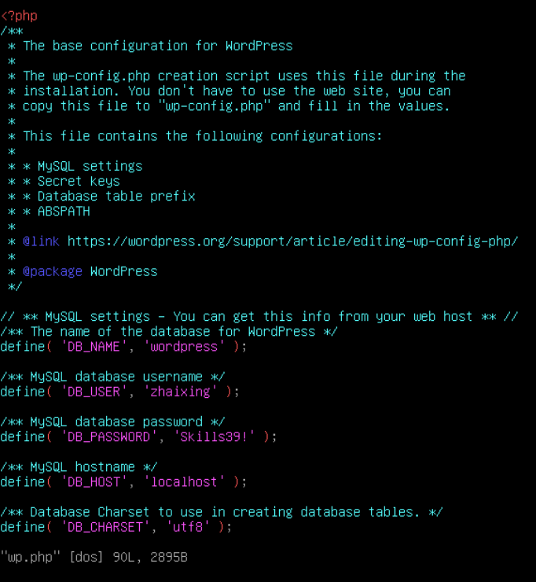

default


