A模块 校内选拔 解题思路

做题顺序
1. ansible 主机初始化 (server1 server2)，并创建快照
2. 完成其他机器的初始化
3. 网络环境 iptables nat 部分,路由转发
4. dhcp chrony
5. nfs
6. CA

ansible 主机初始化 (server1 server2)
apt install ssh python3 -y

echo "
auto ens33
iface ens33 inet static
address 192.168.1.101/24
gateway 192.168.1.254" >> /etc/network/interfaces

echo "" > /etc/resolv.conf
systemctl restart ssh networking

其他主机初始化 (server3 server4 ISP router server remote)

apt install vim man less curl wget lynx dnsutils ftp lftp nfs-common smbclient ssh telnet traceroute ntpdate lsof nmap mailutils bash-completion -y

systemctl restart dbus
hostnamectl set-hostname server4
localectl set-x11-keymap us
timedatectl set-timezone Asia/Shanghai

echo 'PermitRootLogin yes' >> /etc/ssh/sshd_config
echo 'syntax on

set nu' >> /etc/vim/vimrc
systemctl restart sshd

网络环境 iptables nat 部分apt ,路由转发
- router
apt install iptables -y
iptables -t nat -A POSTROUTING -s 172.16.1.0/24 -d 47.119.161.16/28 -j SNAT --to 202.96.128.253
iptables -t nat -A PREROUTING -d 202.96.128.253 -m multiport -p tcp --dport 80,443,465,993 -j DNAT --to 172.16.1.101 ip
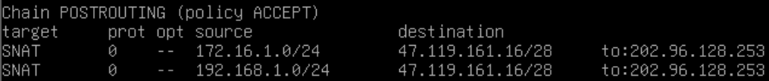apt install iptables-persistent -y
# 测试：server3 ping 47.119.161.25

- router ISP
/etc/sysctl.conf
sysctl -p

dhcp
- ISP
apt install isc-dhcp-server -y
/etc/dhcp/dhcpd.conf
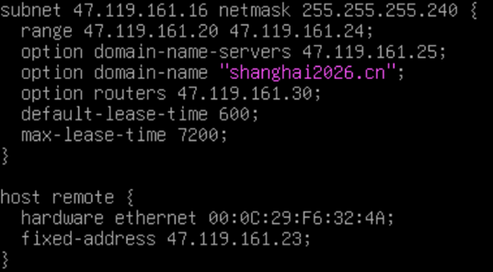
/etc/default/isc-dhcp-server

chorny
- Server
/etc/chrony/chrony.conf
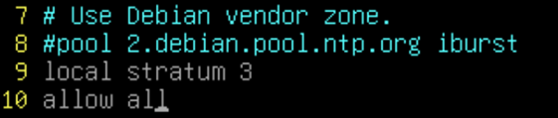
- ISP router server3 server4
# 前提条件 apt install systemd-timesyncd -y
echo ‘NTP=47.119.161.25’ >> /etc/systemd/timesyncd.conf
systemctl restart systemd-timesyncd.service

NFS
- server4
apt install nfs-kernel-server -y
mkdir /website
/etc/exportfs
exportfs -av
- server3
# apt install nfs-common -y
/etc/fstab
mkdir /htdocs/html -p
mount -a
# 测试：

CA
- server
/etc/ssl/openssl.cnf
#创建CA根证书
mkdir /etc/ssl/Shanghai-CAu
cd /etc/ssl/Shanghai-CA
cd
# CN
# WSC2026
# Shanghai-CA
#创建第一张证书并签发（给router用的）
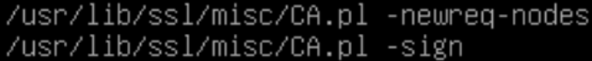
# FR
# WSC2024
# router.lyon2024.fr
mkdir /ssl/etc/tls

#命令行信任根证书（server,router,server3,remote）
server# cp /root/demoCA/cacert.pem /ssl/ca.crt #方便后面操作用于给客户端信任根证书
#创建目录并存储根证书
#创建第二张证书（给server3用的）
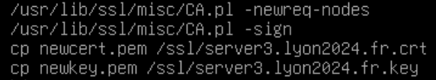
#将第一张证书和第二张证书分别拷贝到router和server3使用
server# scp /ssl/* root@202.96.128.253:/etc/ssl/tls

server3# scp root@47.119.161.25:/ssl/* /etc/ssl/tls

DNS
- server
apt install bind9 -y
/etc/bind/named.conf (文件参考/etc/bind/named.conf.defaults)
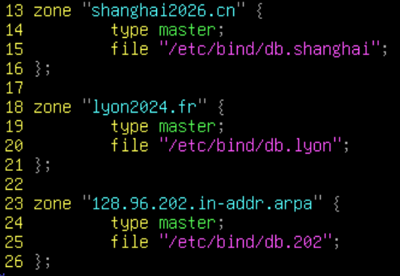
/etc/bind/db.shanghai(文件参考/etc/bind/db.local)
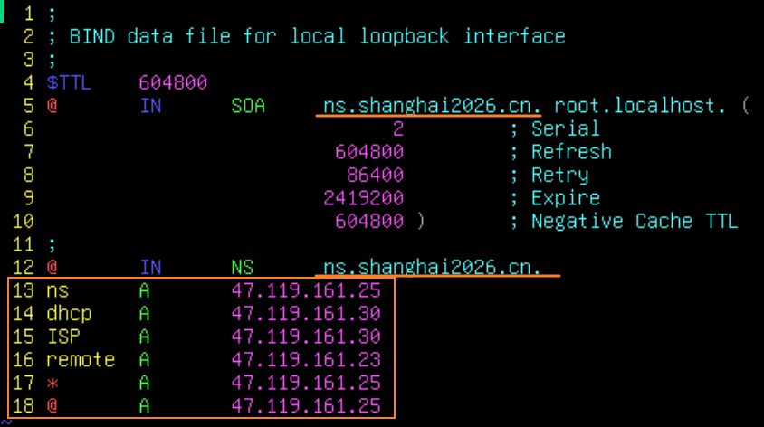
/etc/bind/db.lyon
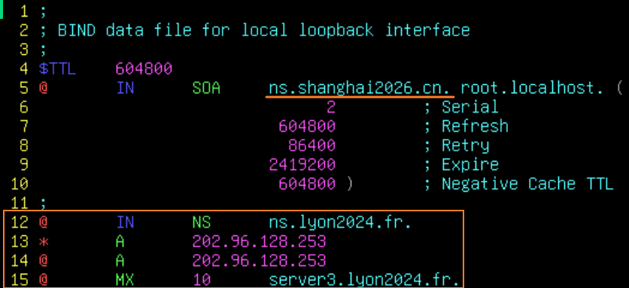
/etc/bind/db.202(文件参考/etc/bind/db.127)
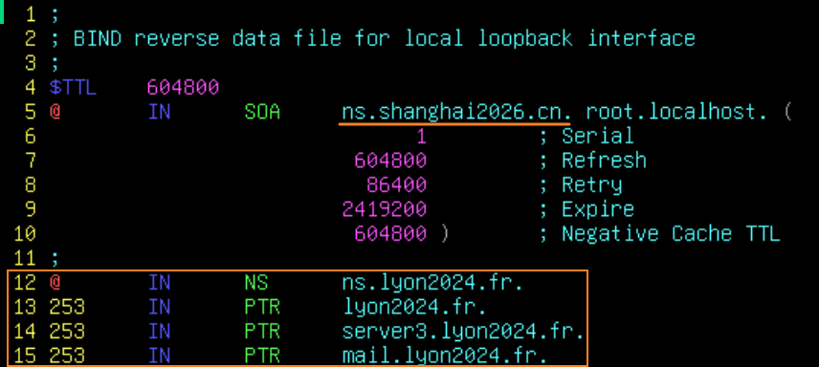

WEB apache2
- server3
apt install apache2 -y
useradd webuser
/etc/apache2/envvars
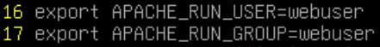
/etc/apache2/sites-enabled/000-default.conf
(参考文件/etc/apache2/sites-available/default-ssl.conf)
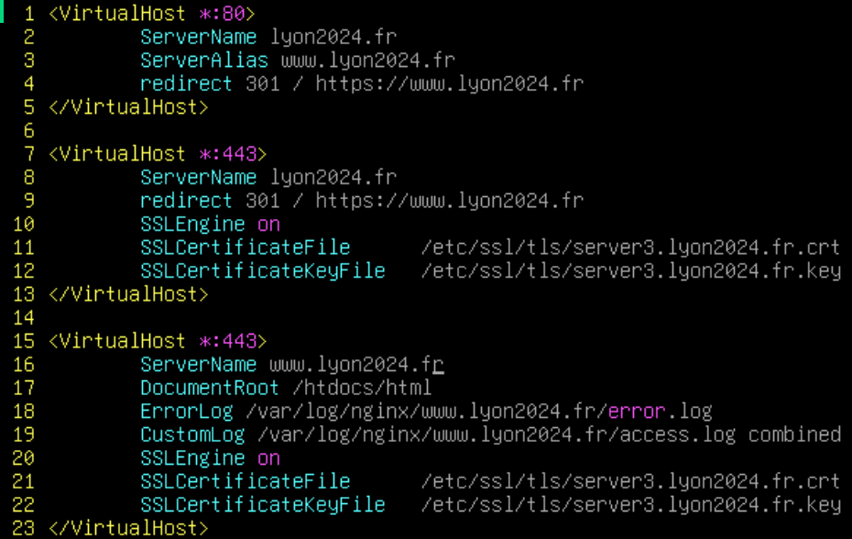
/htdocs/html/index.html
/etc/apache2/apache2.conf
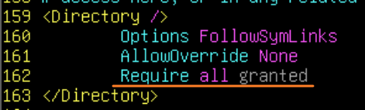
mkdir /var/log/nginx/www.lyon2024.fr -p
a2enmod ssl
systemctl restart apache2
cp /etc/ssl/tls/ca.crt /htdocs/html
# firefox Client 导入证书（remote）
- 下载根证书
2. 浏览器信任根证书
3. 命令行信任根证书
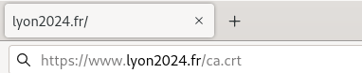

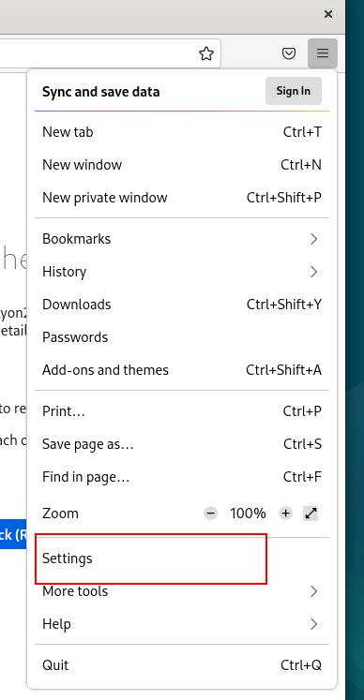
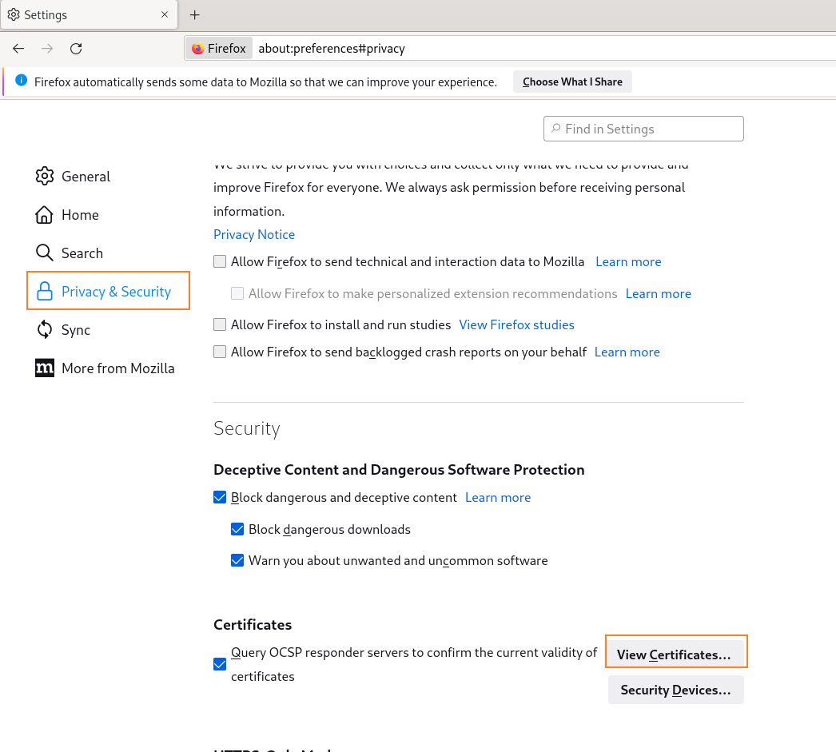
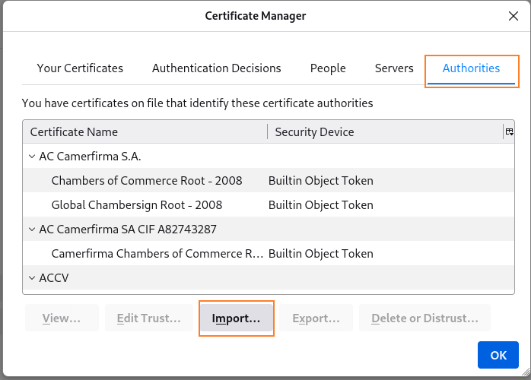
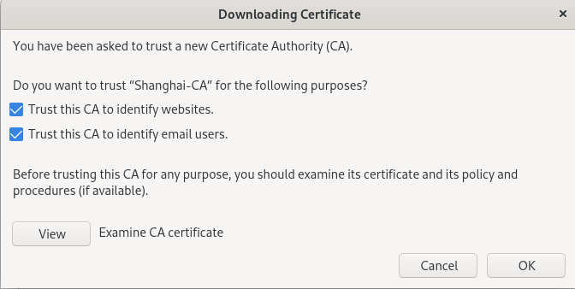
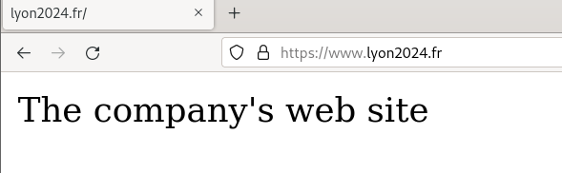
#命令行信任
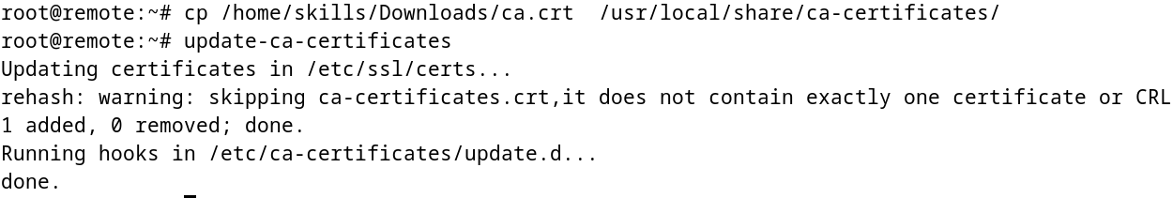

MAIL postfix dovecot
- server3
apt install postfix dovecot-imapd -y
# server3.lyon2024.fr
#检查/etc/hosts 文件
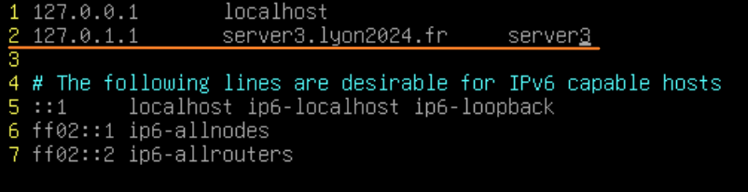
/etc/postfix/main.cf
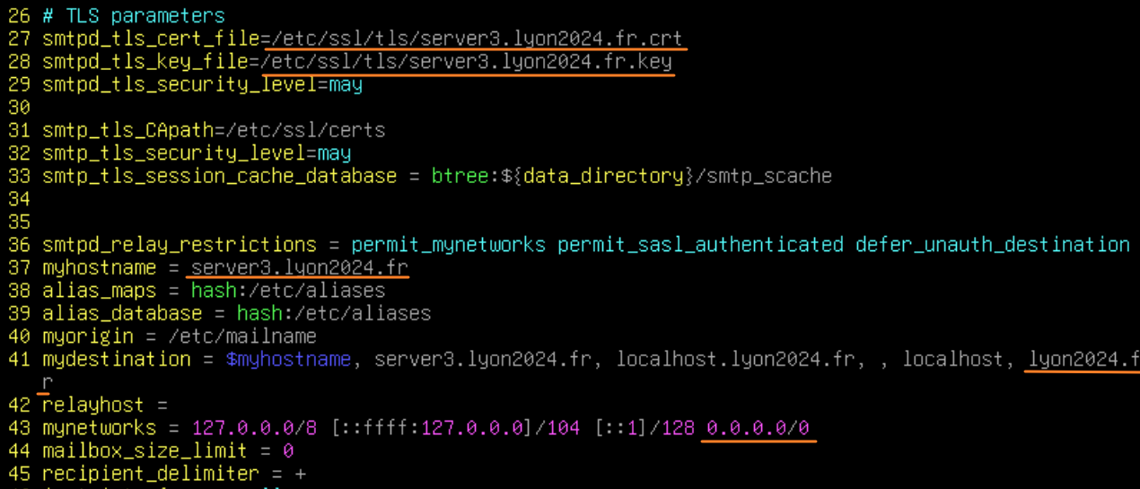
/etc/postfix/master.cf
/etc/dovecot/conf.d/10-auth.conf
/etc/dovecot/conf.d/10-ssl.conf
/etc/dovecot/conf.d/10-master.conf
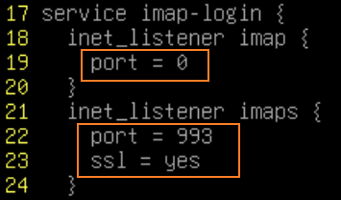
编写配置文件重启服务
systemctl restart dovecot
systemctl restart postfix
useradd -m zhangsan
useradd -m lisi
echo "zhangsan:GDSkills-2023" | chpasswd
echo "lisi:GDSkills-2023" | chpasswd
/etc/aliases

postalias /etc/aliases

Mail Client
- remote
#确保邮件客户端有网关，以及能够解析邮件记录，MX记录。
打开Evolution 软件
#导入根证书（可选，如果不导入，就在首次登录的警告中选择最右边的选项Permanent trust 永久信任）
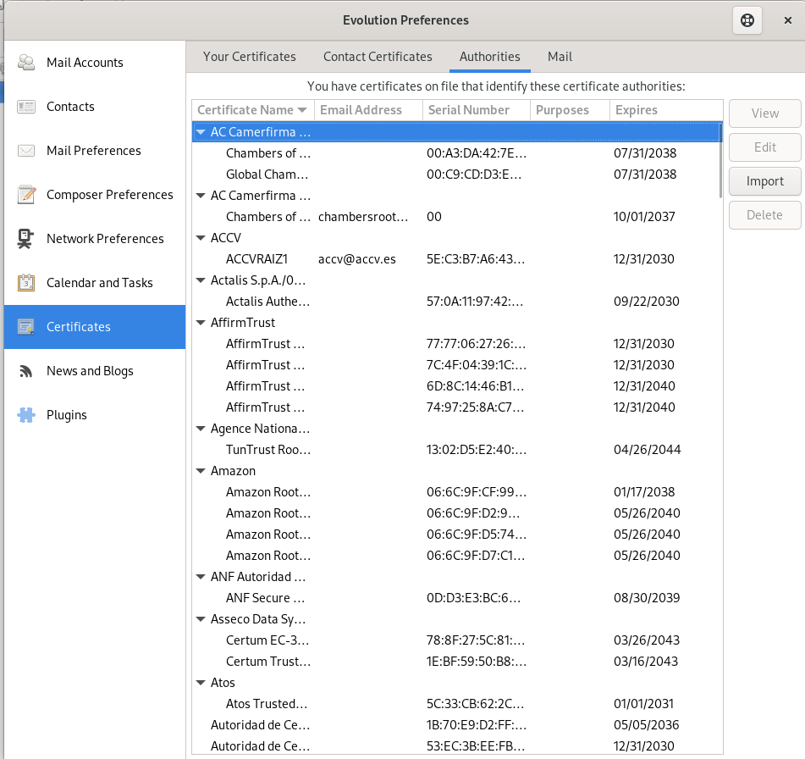
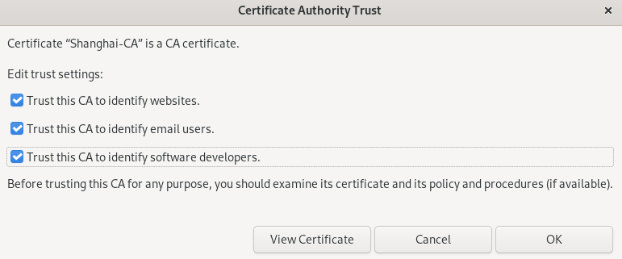
#配置邮件 用户

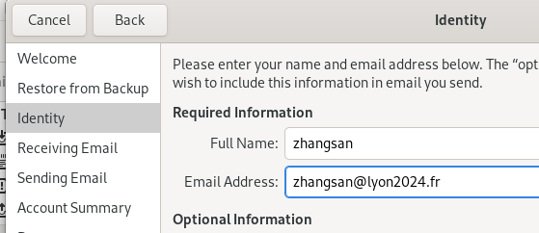
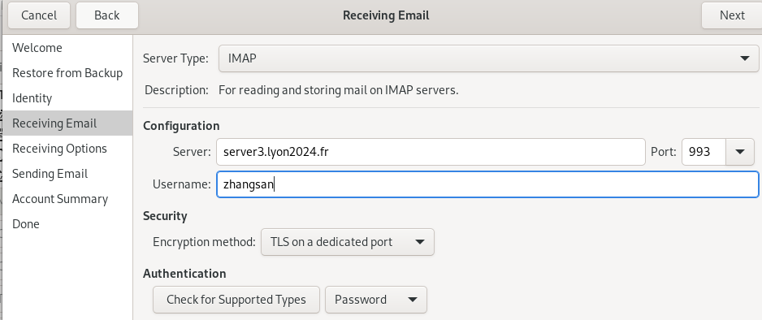
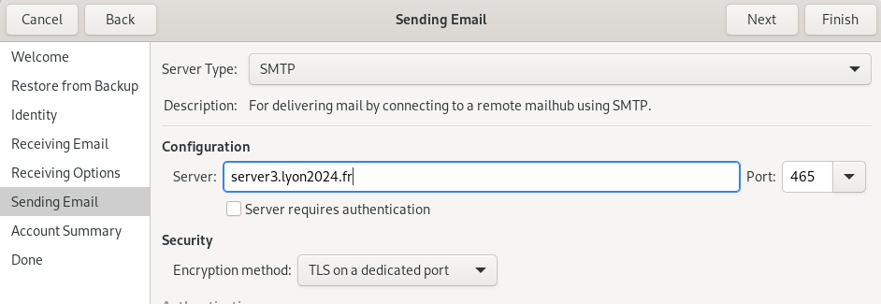
#创建完zhangsan用户后，把lisi用户也创建，同样的步骤
#收发邮件测试，以及群发邮件测试：
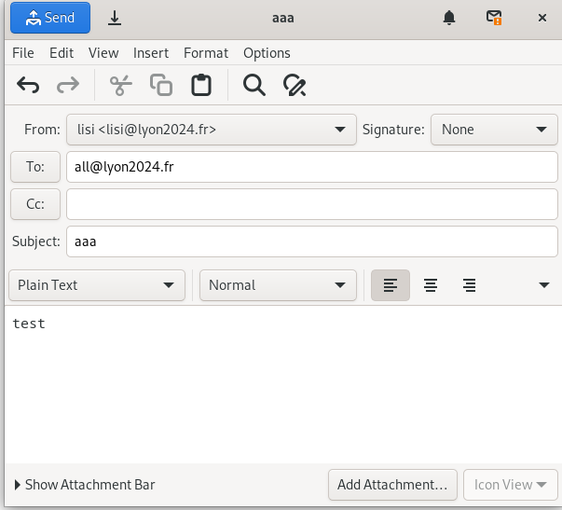

SSH
- remote

#登陆skills用户创建ssh key，无需输入密码
ssh-keygen -t ed25519
#拷贝密钥到router上的skills用户exit
ssh-copy-id skills@router.lyon2024.fr
su - (进入root)
cp /home/skills/.ssh/ /etc/skel/ -r
/etc/ssh/ssh_config
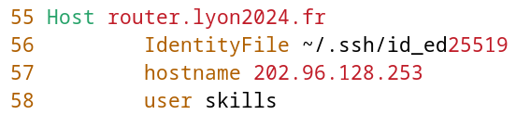
- router
apt install sudo -y
visudo

#在skills用户中进行配置以下步骤
vim /home/skills/.bashrc

source /home/skills/.bashrc

OPENVPN
(使用静态key,不能完全达到效果，晚点再配置ca证书的方式)

- router
apt install openvpn -y
openvpn --genkey secret static.key
/etc/openvpn/server.conf
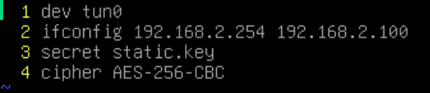
scp static.key root@47.119.161.23:/root/
- remote
apt install openvpn -y
cp static.key /etc/openvpn/
/etc/openvpn/client.conf
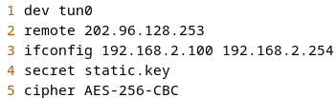
/etc/network/interfaces

FIREWALL iptables
- router
apt install iptables -y

iptables -A INPUT -m state --state ESTABLISHED,RELATED -j ACCEPT
iptables -A INPUT -p udp --dport 1194 -j ACCEPT
iptables -A INPUT -s 192.168.1.0/24 -p tcp --dport 22 -m recent --update --seconds 60 --hitcount 3 -j DROP
iptables -A INPUT -s 172.16.1.0/24 -p tcp --dport 22 -m recent --update --seconds 60 --hitcount 3 -j DROP
iptables -A INPUT -p ICMP -j DROP
iptables -A INPUT -j ACCEPT
iptables -P INPUT DROP

iptables -A FORWARD -m state --state ESTABLISHED,RELATED -j ACCEPT
iptables -A FORWARD -p tcp -m multiport --dport 80,443,465,993 -j ACCEPT
iptables -A FORWARD -p udp --dport 123 -j ACCEPT
iptables -A FORWARD -s 192.168.2.0/24 -d 192.168.1.0/24 -j ACCEPT
iptables -A FORWARD -j ACCEPT
iptables -P FORWARD DROP
iptables-save > /etc/iptables/rules.v4

ANSIBLE

配置VSC连接到router
- router
- 安装所需要的软件包
apt install sshpass python3 python3-passlib ansible -y
- 打开powershell 通过scp的方式把vscode Linux服务器端的软件包拷贝进去（也可以通过镜像打包的方式）
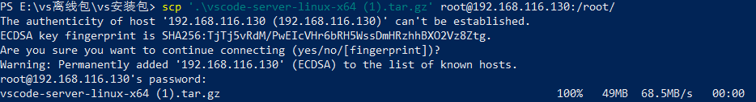
- 通过宿主机的vscode中commit的值来创建目录，并拷贝解压缩后的软件包到里面
- 宿主机（使用vscode写代码的机器）
# 打开vscode
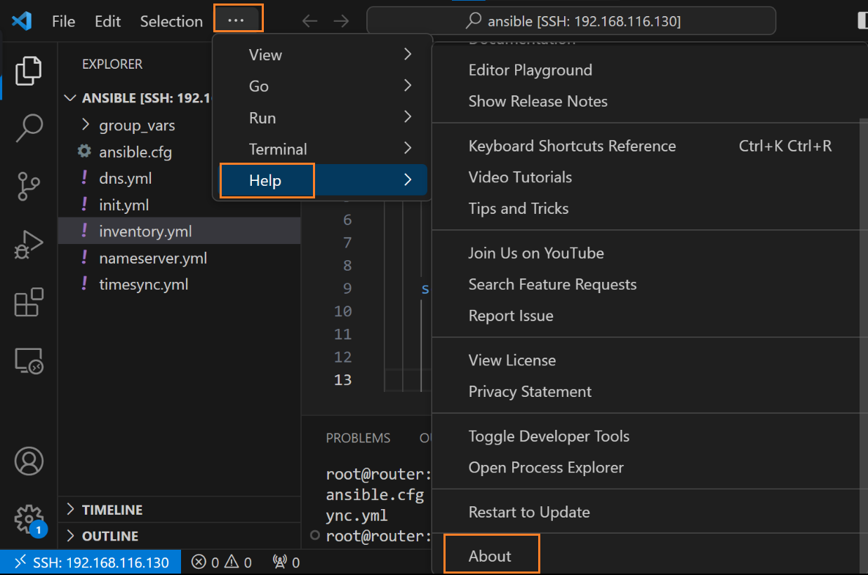
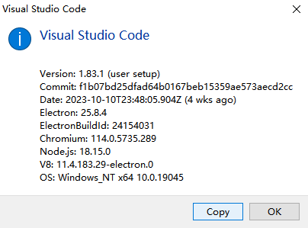
复制出来后，取出Commit中的值复制
- 解压缩软件包，根据刚刚复制的Commit值创建目录路径，拷贝软件到对应目录
- router
- 尝试使用宿主机的vscode 进行连接
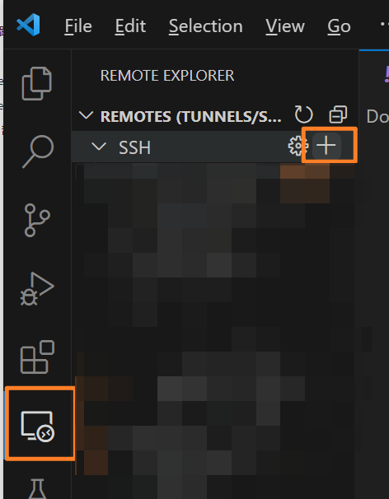
#输入router上的地址
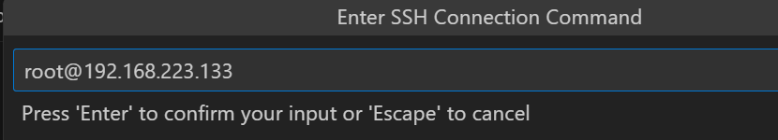
#回车
#点击Connect
#输入密码

#连接成功后可以看到左下角的标识

配置ansible基础环境（ansible.cfg,inventory.yml,linux.yml）
mkdir /etc/ansible
mkdir /ansible/group_vars -p
ansible.cfg (可以通过ansible-config init 的方式进行参考)
/etc/ansible/ansible.cfg
[defaults]
host_key_checking=False
inventory=/etc/ansible/inventory.yml
inventory.yml （inventory清单文件，用于识别对不同主机进行操作和变量的读取）
/etc/ansible/inventory.yml
---
linux:
hosts:
server1:
ansible_host: 192.168.1.101
hostname: server1
dnstype: Master
nameserver: 192.168.1.102
server2:
ansible_host: 192.168.1.102
hostname: server2
dnstype: Slave
nameserver: 192.168.1.101
linux.yml (凭据文件，用于连接ansible被控端，存放在这个路径可以直接被识别，不需要在剧本中声明变量)
/ansible/group_vars/linux.yml
---
ansible_user: skills
ansible_password: GDSkills-2023
ansible_become: true
ansible_become_method: su
ansible_become_user: root
ansible_become_password: GDSkills-2023

编写剧本文件
#如何使用Zeal 文档（只需要）
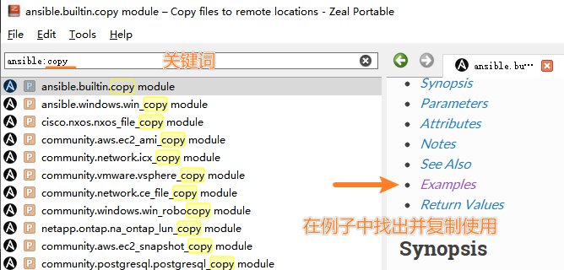
init.yml
/ansible/init.yml
- name: init
hosts: linux
gather_facts: false
tasks:
- name: install nessery packet
ansible.builtin.raw: apt install -y vim python3 python3-passlib dbus curl wget lynx dnsutils ftp lftp nfs-common smbclient telnet traceroute ntpdate lsof nmap mailutils
changed_when: false
- name: restar dbus
ansible.builtin.systemd:
state: restarted
name: dbus
- name: set hostsname
ansible.builtin.command: hostnamectl set-hostname {{ hostname }}
changed_when: false
- name: Set timezone to Asia/Shanghai
community.general.timezone:
name: Asia/Shanghai

timesync.yml
/ansible/timesync.yml
- name: timesync
hosts: linux
gather_facts: false
tasks:
- name: install nessery packet
ansible.builtin.raw: apt install -y systemd-timesyncd
changed_when: false
- name: configure systemd timesyncd
ansible.builtin.lineinfile:
path: /etc/systemd/timesyncd.conf
regexp: '^#NTP='
line: NTP=47.119.161.25
- name: restar systemdtimesyncd
ansible.builtin.systemd:
state: restarted
name: systemd-timesyncd
changed_when: false
nameserver.yml
/ansbile/nameserver.yml
- name: nameserver
hosts: linux
gather_facts: false
tasks:
- name: set resolv conf
ansible.builtin.copy:
src: /ansible/group_vars/{{ hostname }}.resolv.conf
dest: /etc/resolv.conf
dns.yml
/ansible/dns.yml
- name: dns
hosts: linux
gather_facts: false
tasks:
- name: install bind9
ansible.builtin.raw: apt install -y bind9
changed_when: false
- name: named conf
ansible.builtin.copy:
src: /ansible/group_vars/{{ dnstype }}.named.conf
dest: /etc/bind/named.conf
- name: db
ansible.builtin.copy:
src: /ansible/group_vars/db.lyon
dest: /etc/bind/db.lyon
- name: restar bind9
ansible.builtin.systemd:
state: restarted
name: bind9
changed_when: false
# 首先在server1 和server2 上配置好主从服务器，然后将他们的配置文件通过scp的方式拷贝过来db.lyon , Master.named.conf Slave.named.conf ，并以这样的文件名称命名。
db.lyon
/group_vars/db.lyon
;
; BIND data file for local loopback interface
;
$TTL 604800
@ IN SOA ns.lyon2024.fr. root.localhost. (
2 ; Serial
604800 ; Refresh
86400 ; Retry
2419200 ; Expire
604800 ) ; Negative Cache TTL
;
@ IN NS ns.lyon2024.fr.
ns A 192.168.1.101
server1 A 192.168.1.101
server2 A 192.168.1.102
server3 A 172.16.1.101
server4 A 172.16.1.102
www A 172.16.1.101
mail A 172.16.1.101
vpn A 172.16.1.254
router A 172.16.1.254
router A 192.168.1.254
router A 202.96.128.253
Master.named.conf
// This is the primary configuration file for the BIND DNS server named.
//
// Please read /usr/share/doc/bind9/README.Debian for information on the
// structure of BIND configuration files in Debian, *BEFORE* you customize
// this configuration file.
//
// If you are just adding zones, please do that in /etc/bind/named.conf.local

include "/etc/bind/named.conf.options";
include "/etc/bind/named.conf.local";
include "/etc/bind/named.conf.default-zones";

zone "lyon2024.fr" {
type master;
file "/etc/bind/db.lyon";
};
Slave.named.conf
// This is the primary confisguration file for the BIND DNS server named.
//
// Please read /usr/share/doc/bind9/README.Debian for information on the
// structure of BIND configuration files in Debian, *BEFORE* you customize
// this configuration file.
//
// If you are just adding zones, please do that in /etc/bind/named.conf.local

include "/etc/bind/named.conf.options";
include "/etc/bind/named.conf.local";
include "/etc/bind/named.conf.default-zones";

zone "lyon2024.fr" {
type slave;
masters { 192.168.1.101; };
file "db.lyon";
};
server1.resolv.conf
domain lyon2024.fr
search lyon2024.fr
nameserver 192.168.1.102
server2.resolv.conf
domain lyon2024.fr
search lyon2024.fr
nameserver 192.168.1.101

